🚦 Project Report – TrafficTelligence: Traffic Volume Prediction Using Machine Learning

# 1. INTRODUCTION

## 1.1 Project Overview

TrafficTelligence is a web-based AI solution that predicts traffic volume based on various input features like weather, holidays, and time. It leverages machine learning to provide real-time predictions, assisting city planners, commuters, and logistics companies in planning ahead.

## 1.2 Purpose

To build a predictive model that forecasts traffic volume using historical data and make it accessible via an easy-to-use web interface.

# 2. IDEATION PHASE

## 2.1 Problem Statement

Urban traffic congestion is a persistent problem affecting productivity, environment, and quality of life. Anticipating traffic volume can improve infrastructure planning and traffic management.

## 2.2 Empathy Map Canvas

Users: City commuters, municipal planners, logistics companies

Needs: Accurate predictions of traffic volume in various weather and time conditions

Pains: Delays, fuel costs, environmental impact

Gains: Smarter route planning, better scheduling, efficient traffic management

## 2.3 Brainstorming

- Use weather and time-based features for prediction

- Develop a machine learning model

- Deploy the solution via a simple web app

- Ensure it is user-friendly for non-technical users

# 3. REQUIREMENT ANALYSIS

## 3.1 Customer Journey Map

Stage | Action | Tool Used

--- | --- | ---

Input | User provides weather, time, etc. | HTML form

Processing | Flask app processes input | app.py, scaler, model

Output | Prediction is shown on screen | output.html

## 3.2 Solution Requirement

- Clean and preprocessed dataset

- Scikit-learn trained model

- Flask for web deployment

- HTML + Bootstrap for UI

## 3.3 Data Flow Diagram

[User Input Form] → [Flask app.py] → [Data Preprocessing] → [Scaler + ML Model] → [Prediction Output]

## 3.4 Technology Stack

- Frontend: HTML, CSS (Bootstrap)

- Backend: Flask (Python)

- ML Libraries: Scikit-learn, Pandas, NumPy

- Model: Trained regression model with scaling

- Tools: Jupyter Notebook, VS Code

# 4. PROJECT DESIGN

## 4.1 Problem-Solution Fit

By combining machine learning with weather and holiday-based data, we provide a solution that predicts traffic volume effectively.

## 4.2 Proposed Solution

A web-based tool where users input current conditions to receive a traffic volume estimate.

## 4.3 Solution Architecture

- UI collects inputs

- Flask backend transforms and scales data

- Pre-trained model predicts output

- Result rendered in output.html

# 5. PROJECT PLANNING & SCHEDULING

## 5.1 Project Planning

Phase | Timeline

--- | ---

Data Preprocessing | Week 1

Model Training | Week 2

Web App Integration | Week 3

Testing & Launch | Week 4

# 6. FUNCTIONAL AND PERFORMANCE TESTING

## 6.1 Performance Testing

- Model evaluated on MAE and RMSE

- Prediction latency tested on local server

- Input combinations tested for reliability

# 7. RESULTS

## 7.1 Output Screenshots

- index.html: Form to input weather, date, and time

- output.html: Displays predicted traffic volume{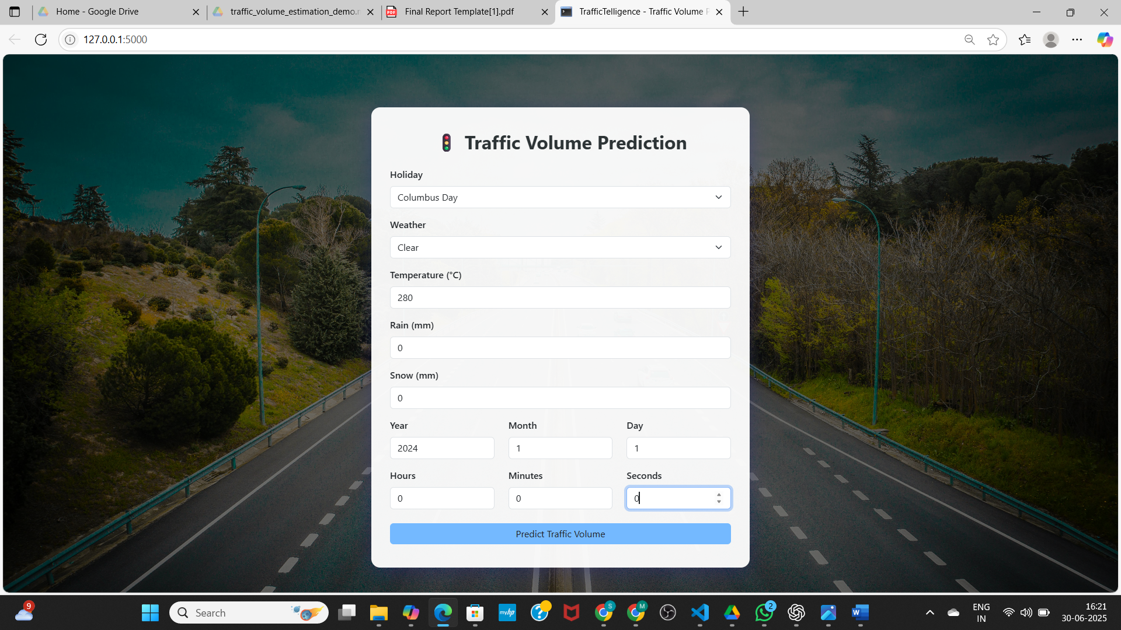}

{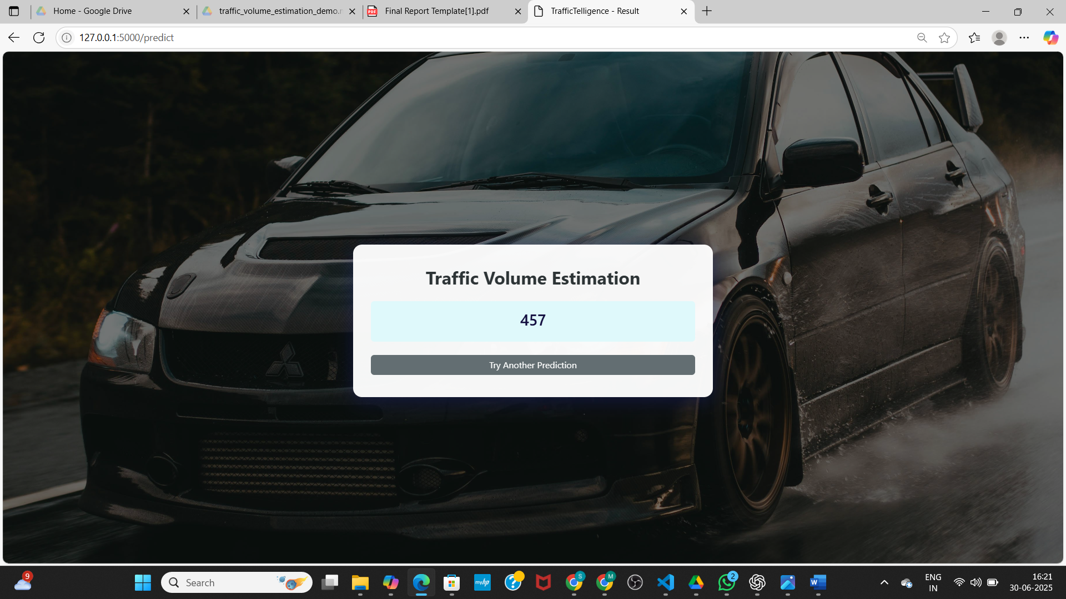)

# 8. ADVANTAGES & DISADVANTAGES

## Advantages

- Real-time, user-friendly prediction system

- Scalable to other cities and more features

- Can aid in traffic and event planning

## Disadvantages

- Trained on a fixed dataset; accuracy may drop for unusual conditions

- Model needs updates with newer data to stay accurate

# 9. CONCLUSION

TrafficTelligence demonstrates how machine learning can enhance urban mobility by predicting traffic volume using environmental and temporal data. The project bridges AI technology with practical city-life applications.

# 10. FUTURE SCOPE

- Integrate live traffic data APIs

- Add route-level prediction

- Implement mobile app version

- Support multiple cities with geo-tagged data

# 11. APPENDIX

- Source Code: Included in app.py, HTML templates, and notebook

- Dataset Link: traffic_volume.csv (https://drive.google.com/file/d/1iV5PfYAmI6YP0_0S4KYy1ZahHOqMgDbM/view)

- GitHub: https://github.com/peddisettymahesh07/traffic_voulme_estimation

Demo Link: https://drive.google.com/file/d/1jtsDXGOVKjqRhjv7iOTYf5YwaDIsIiU_/view?usp=sharing